**Learning Objective**

We can use the apostrophe to indicate possession with both singular and plural nouns.

**Challenge 1**

**Complete the following sentences by choosing the correct word from the list below:**

**nest’s**

**America’s**

**rhea’s**

**flock’s**

**rheas’**

**winner’s**

1. During the fight, the ___________ necks twisted together.
2. To help it balance, and change direction more smoothly, the __________ large wings spread out above his head.
3. The ____________ prize was the female rhea.
4. The male rhea carefully looks after the ____________ eggs for 6 weeks.
5. South ____________ grasslands are the main home of the rhea.
6. The ____________ members can be made up of a mixture of different animals, such as deer.

**Challenge 2**

**Finish these sentences with your own words, paying attention to the position of the apostrophe.**

1) The males’ fighting skills __________________________________________________

2) The farmers’ crops _____________________________________________________ 3) The rheas’ enormous wings ________________________________________________

4) South America’s rhea population ____________________________________________

5) The female’s eggs ______________________________________________________

6) The rhea’s beak ________________________________________________________

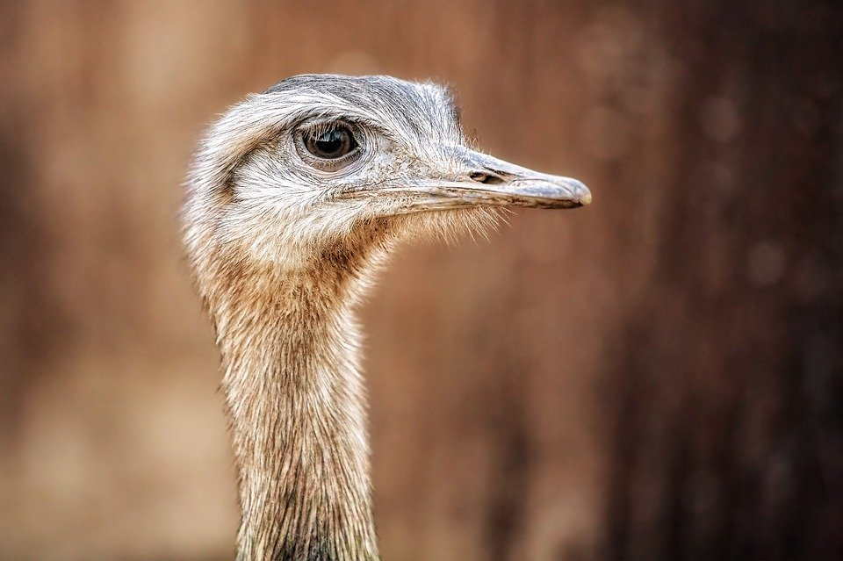

twisted necks

aggressive

bottled

reared up

enormous wingspan

fierce beaks

locked together

rhea’s (one)

powerful legs

rheas’ (more than one)

**Word Wall**

**Challenge 3  
Using the Word Wall, write a short description of the dance fight between the two rheas. Can you include apostrophes for possession in your writing? Try to include sentences which show possession with both singular (one) and plural (more than one) nouns.**