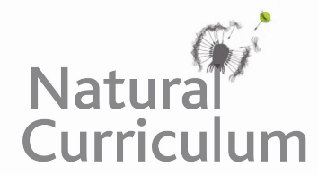**Learning Objective**

We are learning to use the first 2 or 3 letters of a word to check its spelling and meaning in a dictionary.

**Challenge 1**

**Match the words with the correct definitions using a dictionary to support you.**

scales a dry landscape with few plants

scurry a fixed pattern of behaviour in animals

nutrient bony plates found on fish and reptiles

instinct a substance that is needed for plants and animals to grow

barren to move quickly

**Challenge 2**

**Here are some animals that, like the salt flat lizard, can also be found in the Atacama Desert. Sort the animals into alphabetical order (A first, Z last).**

**flamingo hummingbird fox vicugna viscacha lava lizard scorpion**

|  |  |  |  |  |  |  |
| --- | --- | --- | --- | --- | --- | --- |
|  |  |  |  |  |  |  |

**Challenge 3**

**Use your dictionary skills to find the definitions of the words in bold and create a glossary for the paragraph below. The glossary has been started for you to copy and complete (boxed). Notice how the words appear in the glossary in alphabetical order.**

The Atacama is a **desert** in northern Chile. It is one of the driest places on earth. This barren **wilderness** makes it difficult for animals and plants to survive there. In fact, some parts of the desert have never recorded **precipitation** and are so **arid** that no plant or animal life can survive. Salt flat lizards are only able to survive in the Atacama because they get the **moisture** that they need from the flies that they **devour**.

**Glossary**

**Arid** - an area so dry that few plants can grow

**Desert**- an area covered with sand or rocks where very little rain falls

**Devour** – to eat up greedily or ravenously