**Learning Objective**

We are learning how to proofread for spelling, punctuation and grammar errors.

**Challenge 1**

**These sentences are sick and need you to fix them!**

**Some sentences have more than one mistake (linked to our CUPS grammar tips earlier), so you will have to really focus on whether or not they make complete sense!**

* Tuna fishing is one of the bigest treats to spinner dolphins. However some tuna companys now use dolphin-safe fishing methods that release dolphins if they get catched in the nets.
* Dolphins will slap the surface of water to communicate with other dolphins that there is food danger or that the pod is moving somewhere knew.
* Dolphins can be found in wide range of aquatic enviroments and in tempratures ranging from less than 0°C to more than 30°C.
* Dolphins make a variaty of sounds whistles clicks squawks squeeks moans barks groans and yelps.

**Challenge 2**

**Using your own spelling, punctuation and grammar choices, complete the following sentences:**

1. ______________________________ these animals usually spend their time resting at inlets, often using the same locations every day.
2. During the night time hours, __________________________________________ .
3. These carnivorous cetaceans mainly feed upon ____________________________ as well as ____________________ .
4. According to the IUCN Red List, the total population size of the Spinner dolphin is _____________________________ which means________________________ .
5. These dolphins are very playful mammals _________________________________ .

**Challenge 3   
Using the Word Wall to guide your thoughts, write 5 different sentences about spinner dolphins.**

You should use the CUPS method to proofread your work, but make sure that you try to include the following to make your sentences more interesting to your reader:

* relative clause or parenthesis
* subordinate conjunction
* colon (for introducing a list)

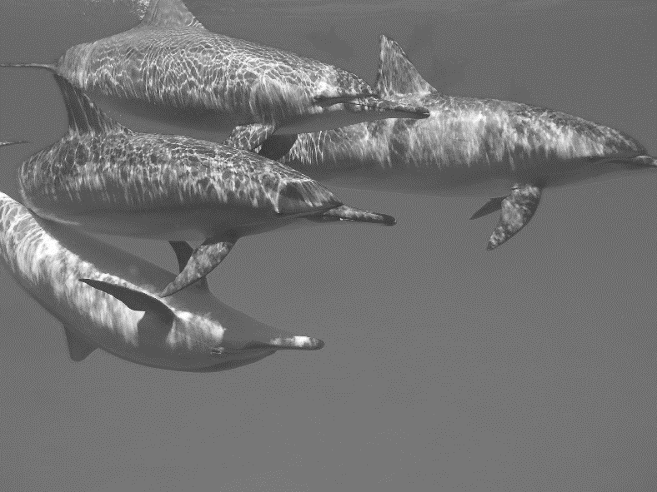

**Word Wall**

prowess

leap

stenella longirostris

tracking

echolocation

exuberant

endangered

cetaceans

unpredictable