**Learning Objective**

We are learning how to start sentences in a variety of interesting ways.

**Challenge 1**

**Using link lines, match each sentence starter to the correct sentence ending.**

|  |  |  |
| --- | --- | --- |
| Like an Olympic diver, |  | the youngster clung to his mother with a tight grip. |
| Exhausted, |  | the crocodiles would not let the monkeys pass. |
| Lazily, |  | the male lounged in the fork of the tree whilst stuffing leaves into his mouth. . |
| Terrified that he might fall, |  | the bold proboscis monkey plunged into the river. |
| Protecting Borneo’s incredible wildlife, |  | the mother finally reached the safety of the riverbank. |
| Like soldiers on patrol, |  | is essential for the planet. |

**Challenge 2**

**Complete the following sentences. Notice how they all start in a really interesting way.**

1. Moving quickly through the water, _______________________________________
2. Cautiously, the brave proboscis monkey ___________________________________
3. Watching from the other side of the river, ________________________________
4. Like a skydiver in free fall, ____________________________________________
5. Screeching and whooping, _____________________________________________
6. Equipped with razor-sharp teeth, ________________________________________
7. Hungrily, __________________________________________________________

**Challenge 3  
Write your own David Attenborough style script to accompany the main clip. Don’t forget to describe through your senses and experiment with a range of interesting sentence starters (see below). Try also to use some of the descriptive words from the Word Wall. You might like to use the following sentence to get you off the starting block:**

*On a branch, high above a river, a family of proboscis monkeys were preparing themselves for a dangerous journey.*

**Interesting sentence starter reminder:**

* Start with an ‘ed’ or ‘ing’ ending verb
* Start with a ‘ly’ ending adverb
* Start with a simile

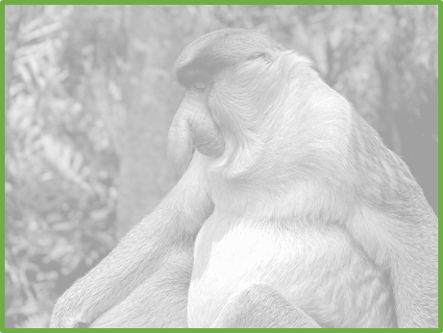

*––*

**Word Wall**

lurking

crocodile infested

splashing

bulbous nose

exhausted

webbed feet

curiously

clinging

proboscis monkey

bravely

terrified

cautiously