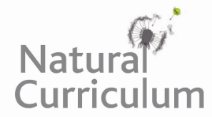

**Learning Objective**

We are learning how to write sentences that use powerful verbs to create precise images.

**Challenge 1**

**Highlight the powerful verbs in the paragraph below.**

The rusty-spotted cat peeked out from behind the leaf, before prancing nimbly across the forest floor. Manoeuvring through its natural habitat, the feline prowled through the undergrowth. As he approached the river, he surveyed his surroundings. Cautiously, he waded through the water. From the middle of the stream, he leapt to the dry land on the other side. Despite his kitten-like appearance, the rusty-spotted cat acted like he was ‘the king of the jungle’.

**Challenge 2**

**Complete the following sentences with a verb that will paint a precise image in the reader’s mind.**

1. The rusty-spotted cat ______________________ across the river.
2. ______________________ around the forest, the feline felt proud and bold.
3. Despite its tiny size, the cat ______________________ like a lion.
4. As the branch snapped, the rusty spotted cat ______________________ to the ground.
5. The daring feline _____________________ through the undergrowth.
6. Waking from its slumber, the cat _______________________ its tiny legs.
7. The frightened cat ______________ in the cave to ______________ the forest’s large predators.

**Challenge 3   
Imagine you are a member of the camera crew, determined to capture the rusty-spotted cat on film in its Sri Lankan forest home. As you walk through the lush undergrowth, the forest comes alive with sound. You think you see some subtle movement in the distance, and there it is – the rusty-spotted cat!**

**Using some of the words in the Word Wall, write a description of what you see. It should include lots of powerful verbs to describe the way the cat moved through the forest and your reaction to this incredible sight.**

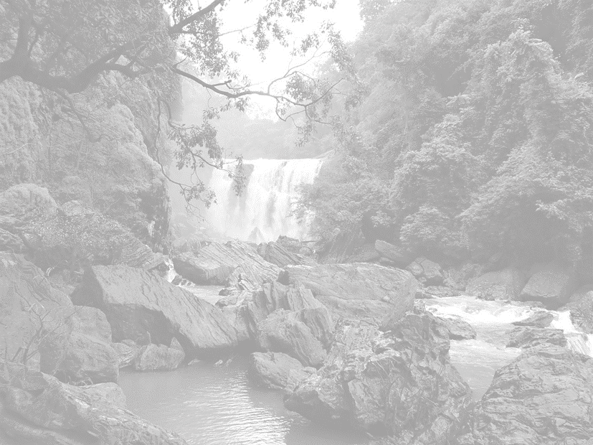

**Word Wall**

rusty-spotted cat

daring

curious

solitary life

super senses

inquisitive

tentative

waded

stumbled

leapt

bounded