
Learning Objective
We are learning how to use prepositions to show a relationship, typically in terms of place and time, between two or more things, people or events.

Challenge 1
These sentences have been split into two and mixed up. Can you use link lines to match them up? Once you have done this, highlight the preposition in each sentence.

Under its chin, the Draco lizard has a
Flying between the trees,
The female Draco needed to climb
Without a sound, the Draco lizard landed
The amazing flying Draco lizards
Scampering across the forest floor
on another tree, high above the forest floor.
live in the jungles of Southeast Asia.
is dangerous because of the many predators that lurk there.
flag, which it opens to warn other creatures away.
the Draco lizards were using their flaps of skin to escape danger.
down the tree to lay her eggs.

Challenge 2
Complete the sentences in the following passage by choosing the most appropriate time, place or movement preposition.

The Draco lizards live high up ____ the trees of the Southeast Asian jungles. They survive ____ using their wings to escape trouble. They move ____ the trees and avoid using the jungle floor. When the Draco lizards leap, they can travel _______ one hundred metres. Their tails trail ____ them and control the direction they move in. This adaptation has allowed them to escape ___ safety.

Challenge 3
Snow leopard
Using some of the prepositions and descriptive words from the Word Walls, write your own scintillating sentences about the Draco lizards featured in the film clip.
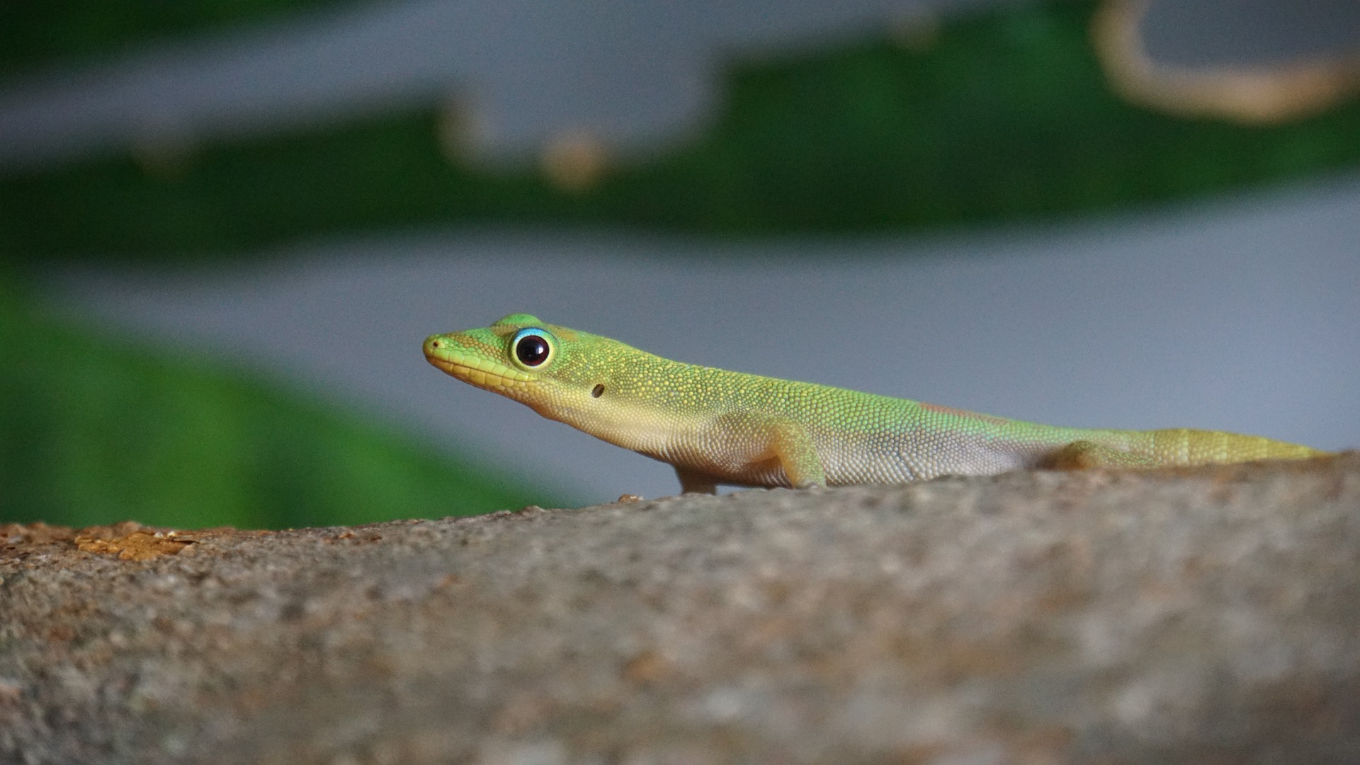
Draco
jungle
folded skin
triangular flag
intimidating
leapt
battled
glided
soared
behind
during
through
after
upon
before
inside
Descriptive Words
Prepositions

